MIDTERM – Fall 2015
CS583: Data Ming and Text Mining

Name:_____________________________ UID:__________________________

Instruction:
- This is a close book examination
- The paper has 7 questions and the full mark is 80.

Marks
Q1
Q2
Q3
Q4
Q5
Q6
Q7
Total

- (10%) Given the following table with three attributes, a1, a2, and a3:
a1 a2 a3
X Y H
Y W S
Y W H
X Y H
G W G
Y E O
G G G
X Y G

We want to mine all the frequent itemsets in the data. Assume the minimum support is 25%. Following the Apriori algorithm, give the set of frequent itemsets in F₁, F₂, …., and candidate itemsets in C₂, C₃, …. (after the join step and the prune step).

- (10%) Sequential pattern mining.
  - Given the minimum support of 25% and the following sequence data, generate all sequential patterns.
Customer ID Customer sequence
1. <{40} {90} {60, 80}>
2. <{20, 30} {40} {50, 70, 80}>
3. <{40, 60, 80}>
4. <{40} {50, 80} {90}>
5. <{50} {90}>
6. <{50, 90}>

(b) Using the same data, if we employ multiple minimum supports with MIS(40) = 50%, MIS(90) = 50% and the MIS values for the rest of the items being 25%, find all sequential patterns (no support difference constraint).

- (10%) Given the following 7 text documents, which are already represented as bags of words, and their classes, compute the probabilities needed for text classification. Ignore smoothing.

Document Class
Teacher, Class, Book : Education
Teacher, Lecture, Class : Education
Teacher, Class, Class, Book : Education
Baseball, Football : Sport
Football : Sport
Baseball, Coach, Coach, Team : Sport
Football, Team : Sport

4. (10%) Given the following dataset with two classes, yes and no, use the information gain criterion to compute the gain value for attribute “credit_rating”. Give the detailed computation.
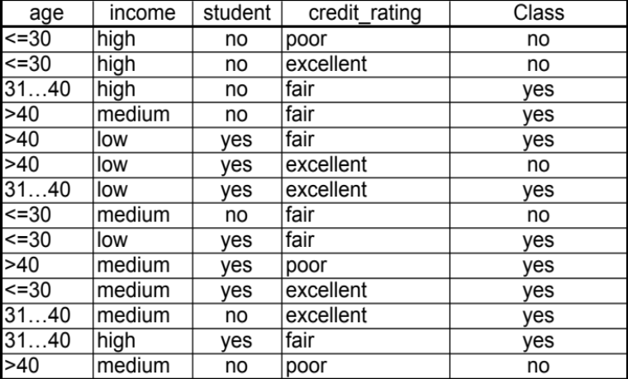

5. (10%) Given the classification results in the confusion matrix below, compute the precision, recall and F score of the positive class, and also the overall classification accuracy.

Classified as |  |  |  | Correct
Positive | Negative | Neutral | Mixed | Correct
50 | 20 | 20 | 20 | Positive
10 | 150 | 10 | 10 | Negative
9 | 5 | 35 | 35 | Neutral
2 | 4 | 5 | 25 | Mixed

6. (10%) We use the following equality in naïve Bayesian classifier. Please prove it.
Pr(A₁=a₁, ..., A_{|A|}=a_{|A|} | C=c_{j})
= Pr(A₁=a₁ | A₂=a₂, ..., A_{|A|}=a_{|A|}, C=c_{j})×Pr(A₂=a₂, ..., A_{|A|}=a_{|A|} | C=c_{j}).

7. (20%) Answer the following questions.
(a). (3%) What do we mean by the following statement: “In computing the decision boundary in SVM, w does not need to be explicitly computed. This is crucial for using kernel functions to handle nonlinear decision boundary.”

(b). (3%) In the linear separable SVM, what is minimized? Give the formula.

(c). (3%) What is the conditional independence assumption used in building Naïve Bayes classifiers? Give the formula.

(d). (3%) What are the mixture weights in Naïve Bayesian text classifiers? How to estimate them?

(e). (2%) Is this statement true or false “In boosting, we basically change the data to produce multiple classifiers”?

(f). (2%) Is this statement true or false “The mixture model is a set of distributions with the same parameters”?

(g). (2%) Is this statement true or false “Decision tree can be applied directly to classifying instances with continuous variables”?

(h). (2%) Give three ways that class association rules can be used for classification?

